Homework 2.

**陳輝**

**01357157**

CSE

* The file name of your homework (in PDF) should be in the format: “學號-作業編

號.pdf”. For example: **00357999-ds-hw2.pdf**

* Please submit your homework to Tronclass before **2025/11/02 23:59**.
* **So, we do NOT accept late submission for this homework.**

**Questions:**

1. (10%) Consider the railroad switching network. Railroad cars numbered 0, 1, 2, …, *n*-1 are at the right. Each car is brought into the stack and removed at any time. For instance, if 𝑛=3, we could move in 0, move in 1, move in 2, and then take the cars out, producing the new order 2, 1, 0. Find all possible permutations for 𝑛=4.

!

"

#

$

"

#

…

"

#

*!*

1. (20%) Given a **stack** of size 4, according to Program 3.1 to 3.3 in the textbook, what is the stack in each step when we do the following commands:

**push J1, push J2, push J3, pop, push J4, push J5, push J6**

|  |  |  |  |  |  |
| --- | --- | --- | --- | --- | --- |
| top | Q[0] | Q[1] | Q[2] | Q[3] | Comments |
| -1 |  |  |  |  | stack is empty |
|  |  |  |  |  |  |
|  |  |  |  |  |  |
|  |  |  |  |  |  |
|  |  |  |  |  |  |
|  |  |  |  |  |  |
|  |  |  |  |  |  |
|  |  |  |  |  |  |

1. (20%) Given a **queue** of size 4, according to Program 3.5 to 3.6 in the textbook, what is the stack in each step when we do the following commands:

**add J1, add J2, add J3, delete, add J4, add J5, add J6**

|  |  |  |  |  |  |  |
| --- | --- | --- | --- | --- | --- | --- |
| front | rear | Q[0] | Q[1] | Q[2] | Q[3] | Comments |
| -1 | -1 |  |  |  |  | queue is empty |
|  |  |  |  |  |  |  |
|  |  |  |  |  |  |  |
|  |  |  |  |  |  |  |
|  |  |  |  |  |  |  |
|  |  |  |  |  |  |  |
|  |  |  |  |  |  |  |
|  |  |  |  |  |  |  |

1. (20%) Given a **circular queue** of size 4, according to Program 3.7 to 3.8 in the textbook, what is the stack in each step when we do the following commands: **add J1, add J2, add J3, delete, add J4, add J5, delete, delete**

|  |  |  |  |  |  |  |
| --- | --- | --- | --- | --- | --- | --- |
| front | rear | Q[0] | Q[1] | Q[2] | Q[3] | Comments |
| 0 | 0 |  |  |  |  | queue is empty |
|  |  |  |  |  |  |  |
|  |  |  |  |  |  |  |
|  |  |  |  |  |  |  |
|  |  |  |  |  |  |  |
|  |  |  |  |  |  |  |
|  |  |  |  |  |  |  |
|  |  |  |  |  |  |  |

1. (20%) Write the postfix form of the following infix expressions:
   1. (A + B) * C + D / (E + F * G) - H
   2. (A && B) || C || ! (E > F)

1. (10%) Write the infix form of the following postfix expression:

# A B C < C D > || ! && ! C E < ||

**Answers:**

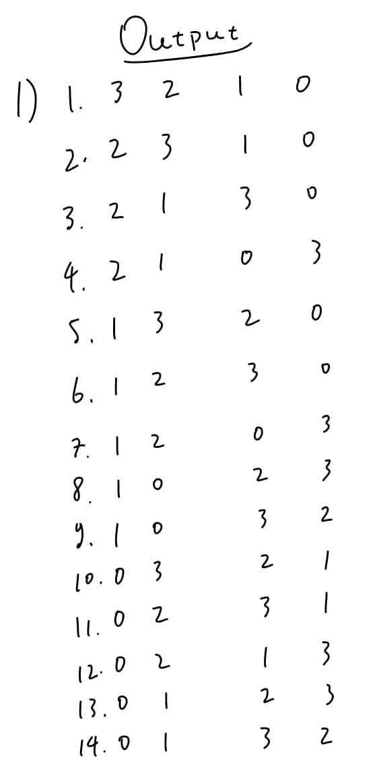

**2)**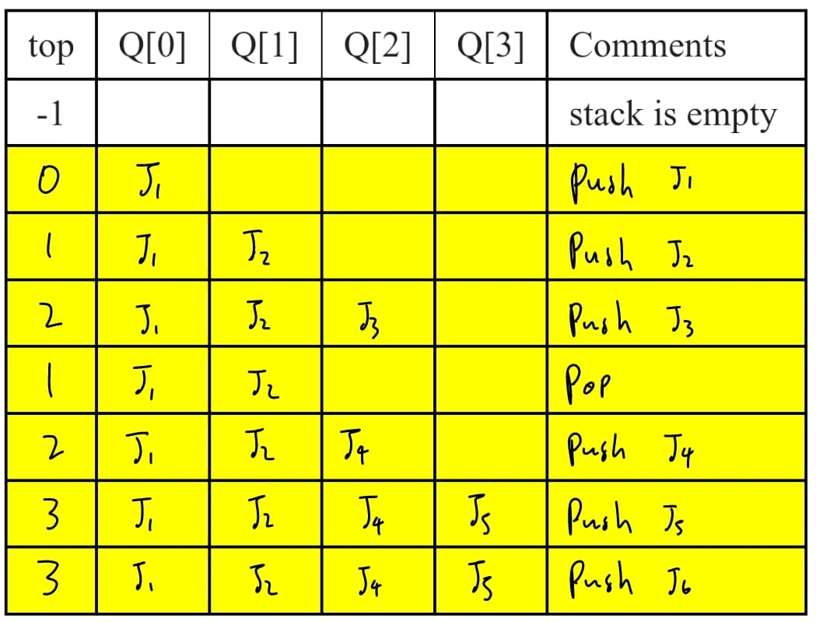

**3)**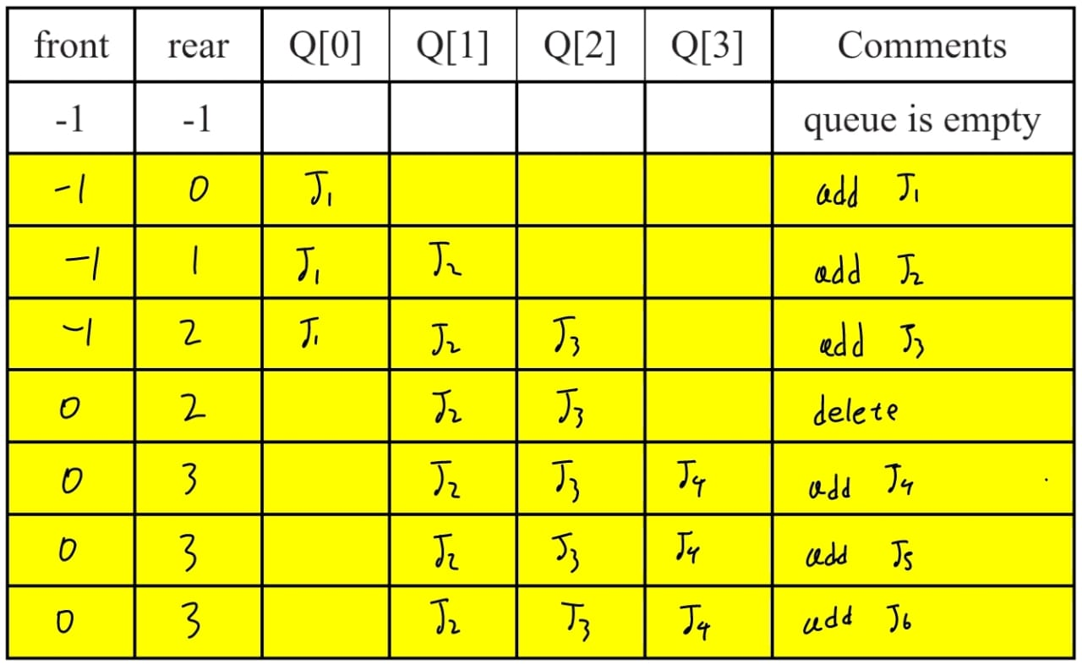

**4)**